**Global Settings**

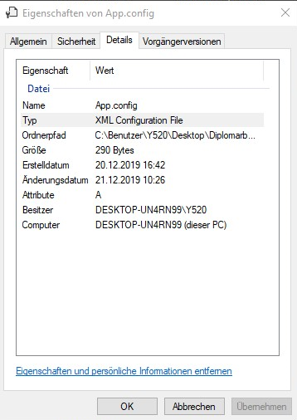 The Global Settings are stored in Visual Studio in the configuration file "app.config" (Figure 3.1) and this file ensures that certain parameters, which are always the same, are set automatically when the application is started. The "app.config" file is kept in XML format and is a central place for application settings, connection details to external services, connection strings to databases and other details about running or hosting the application. The "app.config" file is automatically added to each executable project, which can then be accessed and settings made in the solution. The first setting that the document itself makes is the XML version of the file, as well as the character encoding used for saving. Within the configuration file you have several possibilities to make settings.

**<supportedRuntime/>** Abbildung 4.1

This indicates which "Common Language Runtime version" and optionally the .NET Framework version the application supports.

**<appSettings/>**

Here you can define a key that is assigned a certain character value that can be accessed by this key. These values are stored in the "app.config" file and become the default settings. In our case (Figure 4.2) we have two keys (sensitivity, smoothing).

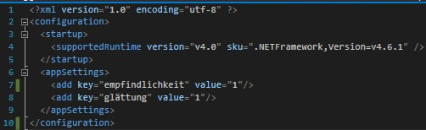

Abbildung 4.2

When a property in the game menu of our project is changed, the new value is assigned to the key and at the same time overwritten and saved. This ensures that after restarting the program the last set values are used. Each Settings form (ClientSettings, ServerSettings) in our project accesses this configuration file via the ConfigurationManager (Figure 4.3) when the respective form is started. When you compile the application, the compiler copies the app.config file into the output directory and it gets a new name. In our case (Start.exe.Config). If you start the application (start.exe) in our case, the appropriate configuration file is loaded as well.



Abbildung 4.3

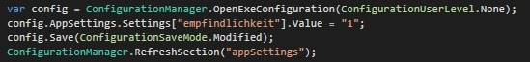

Abbildung 4.4

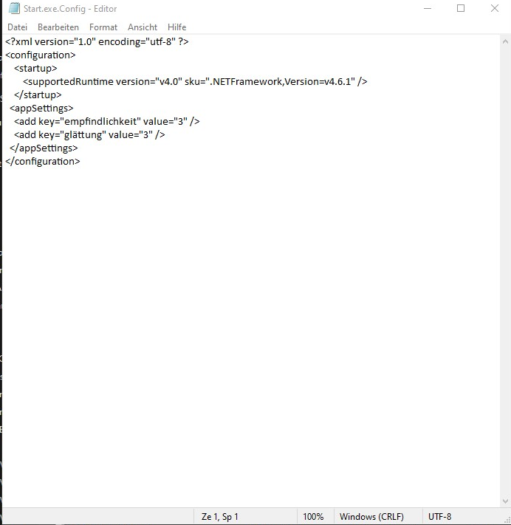

Abbildung 4.5